Hina Sajjad
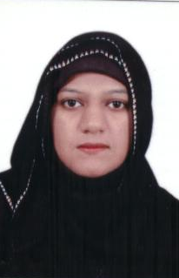

Post Applied for: Office Secretary/Admin Assistant/Receptionist
hina_sajjad43@yahoo.com Cell (+965) 55037506

- CAREER SUMMARY:
SSC followed by 2 year administrative office experience utilizing a wide variety of general office and computer skills. Ability to successfully interact with people at all levels. Office management and multi-tasking skills, working under pressure. Proven interpersonal skills and a team player.

- OBJECTIVES:

Seeking a challenging career position in a growth oriented organization where I can contribute the best of my abilities towards the positive growth and successful development of a progressive organization related to the Administrative & Secretarial position.

- Field Experience

- OFFICE SECRETARY July.2010 to till date.

Al Faisal Mobile & Communication Company.

Responsibilities:
• Receipt, log and distribute the division correspondence, faxes, mail.
• Professional receipt of & greeting of division visitors as well as staff.
• Maintain visitor’s log.
• Receipt and transfer of telephonic calls of division and staff.
• Arrange and log courier pick-up.
• Maintain the staff files and update the files list.
• Keep good level of communication and follow up with staff regarding division administrative issues.
• Keep a good level of communication and co-ordination with secretaries of other divisions.
• Perform the work as per company administration policies and procedure.
• Maintain a good level of confidentiality & safe-guarding of management decisions.
• Maintain a good level of communication & reporting.
• Maintain a week ahead schedule for Manager meetings/appointments.
• Liaise administrative matters between staff and Manager.

- PROFESSIONAL QUALIFICATION:

S.S.C from Federal Board of secondary education Islamabad Pakistan

- IT SKILLS:

Office XP (Word, Excel, Power point, Outlook, Flash, Scanner)
Internet & E-mail Downloading & Uploading.
Typing & Data Entry.

OTHER INFORMATION

- English, Arabic (Average) & (Native Urdu), Hindi & Punjabi.
- Computer Literate
- Female candidate with Transferable Residence
- Self-motivated, Progressive, Hardworking & Dedicated.
- Team Player & Can easily work in multi-national environment.
- Immediately joining and ready to accept new challenges.

